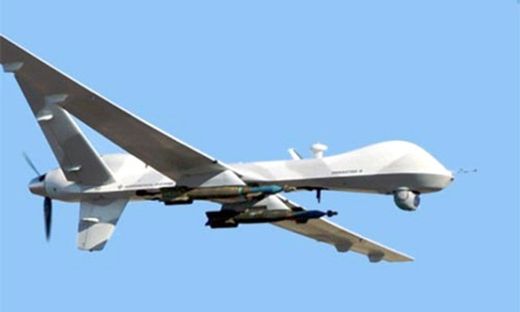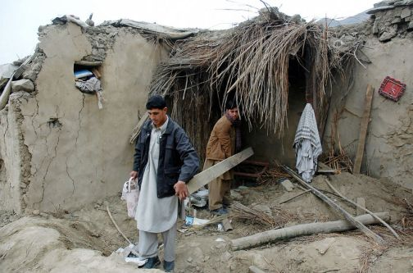

WHY DRONES MUST NOT BE ALLOWED HERE
IN CENTRAL NEW YORK

If you’ve been reading the Syracuse Post-Standard recently you’ll know that drone aircraft (a.k.a. “Reapers”) have recently come to Hancock Air Base.
Drones are robots: unmanned – remote-controlled – aircraft. They are used for surveillance, assassination and bombing.

Although they are unmanned robots, the drones do have “pilots.” But these pilots are operating in cyberspace from control rooms thousands of miles away from the battleground.

The US military is increasingly coming to depend on drones in its various wars overseas. Drones used in Iraq, Pakistan and Afghanistan are piloted from Creech Air Base in Nevada. Beginning this November they will also be piloted from Central New York.

Former Syracuse Congressman, James Walsh, hailed the arrival of drones. Not only do they provide a few jobs, but these killers make it possible for a “pilot” to work all morning (attacking targets in Afghanistan, for example), and “then go home for lunch in Camillus.”

Five reasons why we must oppose the drones in our backyard:

~ Many of us oppose these wars overseas. But without our consent, drones will make Central New York a part of the battlefield.

~ Like many other high-tech weapon systems, drones tend to kill mostly innocent civilians.

~ Because it’s mostly civilians who are maimed and killed, the drones stir up deep hatred. This could lead to retaliation against U.S. civilians, not only overseas, but here. The cycle of violence cannot be stopped by more violence.

~ Because the “pilots” themselves take no risks and never end up killed in action, drones make it easier to go to war. And they make it easier to escalate the wars we’re already in. This leads to a state of perpetual war. As the Viet Nam War era saying went, “War isn’t good for children and other living things.”

~ Drones are cowardly. They are the weapons of rich, powerful nations invading poor, weak nations with few defenses. There is no honor in this.

What to do?

Work to end the wars where drones are being used. Here in CNY you can plug into the Syracuse Peace Council, 315) 472-5478, http://www.peacecouncil.net or http://upstatedroneaction.org.

Write letters to your congress people opposing drones.

Even better: write letters to the editor. A single letter will be read, not only by the influential editors, but also by tens of thousands of readers. Since drones will be housed here in Central New York the key newspaper to write to is the Syracuse Post-Standard [letters@Syracuse.com] or your local newspaper.

Don’t take our word for it. Learn more about the drones and Reapers on your own. You might ask your local library to order a copy of a recent book by a former Pentagon analyst who critically explores the drone issue: P.W. Singer, Wired for War: the Robotics Revolution and Conflict in the 21st Century, Penguin, 2009. Be sure to read chapter 9, “The Refuseniks: The Roboticists Who Just Say No.”###

